Assignment No. 01
Semester: Fall 2025
Course: MTH-202 Discrete Mathematics

Student Information
Student Name: Junaid Jabar
Student ID: Bc240404956

Question: 1 : Let the universal set and its two subsets and be:
𝑈 = {1,2,3,4,5,6,7,8,9,10,11,12}
𝐴 = {𝑥 ∈ 𝑈 ∣ 𝑥 is even}
𝐵 = {𝑥 ∈ 𝑈 ∣ 𝑥² < 50

(a): Draw a Venn diagram for 𝑈, 𝐴, 𝐵 and write the elements in each region.
Answer:
𝑈 = {1,2,3,4,5,6,7,8,9,10,11,12}
A= {2, 4, 6 , 8 , 10, 12}
B= {1, 2, 3, 4, 5, 6, 7}
Venn Diagram :
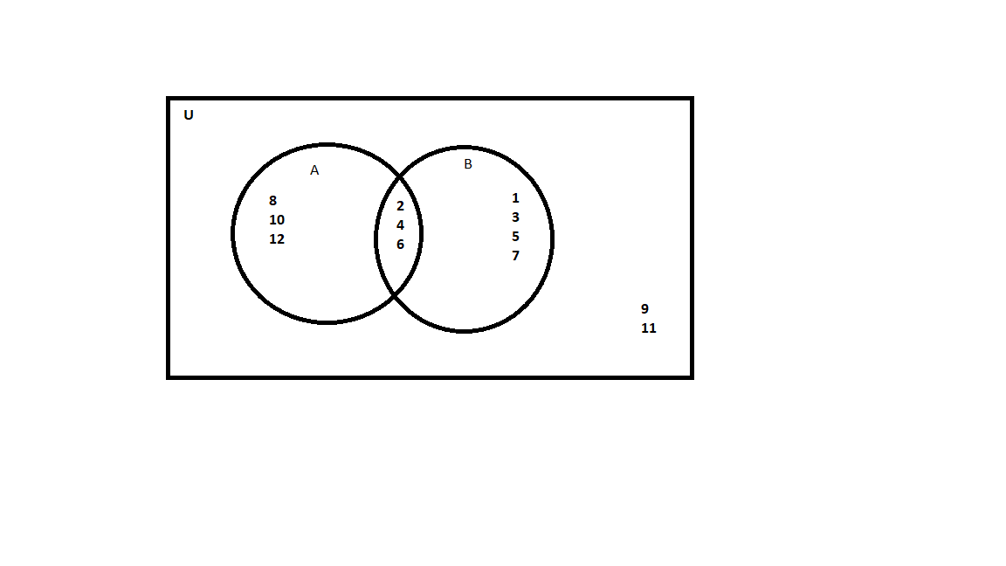
(b): List the elements in:
(1): (complement of )
(𝟐): 𝐴^{𝑐} ∩ 𝐵
(3): A ∪ 𝐵
(4): A ∩ 𝐵
Answer:
(1): A’=U-A
𝑈 = {1,2,3,4,5,6,7,8,9,10,11,12}
A= {2, 4, 6, 8, 10, 12}
U-A = {1,2,3,4,5,6,7,8,9,10,11,12} - {2, 4, 6, 8, 10, 12}
(complement of ) = {1, 3, 5, 7, 9, 11 }
(𝟐): 𝐴^{𝑐} ∩ 𝐵
= From above we have compliment of A
={1, 3, 5, 7, 9, 11 } $∩$ {1,2,3,4,5,6,7}
= {1, 3, 5, 7}
(3): A ∪ 𝐵
A = {2, 4, 6, 8, 10, 12}
B = {1, 2, 3, 4, 5, 6, 7}
A ∪ 𝐵 = {2,4,6,8,10,12} ∪ {1,2,3,4,5,6,7}
={1,2,3,4,5,6,7,8,10,12}
(4): A ∩ 𝐵
A = {2, 4, 6, 8, 10, 12}
B = {1, 2, 3, 4, 5, 6, 7}
A ∪ 𝐵 = {2,4,6,8,10,12} ∩ {1,2,3,4,5,6,7}
= { 2, 4, 6 }

Question: 2: Let p: “I am studying mathematics.” q: “I am going to the library.” be the two statements.
(a): Express negations, disjunction, implication, bi-conditional, and conjunction as statements.
Answer:
p | q | ~p | ~q | p q | p q | p → q | p ↔ q
I am studying mathematics | I am going to the library | I am not studying mathematics | I am not going to the library | I am studying mathematics or I am going to the library | I am studying mathematics and I am going to the library | If I am studying mathematics, then I am going to the library | I am studying mathematics if and only if I am going to the library
I am studying mathematics | I am not going to the library | I am not studying mathematics | I am going to the library | I am studying mathematics or I am not going to the library | I am studying mathematics and I am not going to the library | If I am studying mathematics, then I am not going to the library | I am studying mathematics if and only if I am not going to the library
I am not studying mathematics | I am going to the library | I am studying mathematics | I am not going to the library | I am not studying mathematics or I am going to the library | I am not studying mathematics and I am going to the library | If I am not studying mathematics, then I am going to the library | I am not studying mathematics if and only if I am going to the library
I am not studying mathematics | I am not going to the library | I am studying mathematics | I am going to the library | I am not studying mathematics or I am not going to the library | I am not studying mathematics and I am not going to the library | If I am not studying mathematics, then I am not going to the library | I am not studying mathematics if and only if I am not going to the library

(b): Complete the following table:

p | q | ~p | ~q | p q | p q | p → q | p ↔ q
T | T | F | F | T | T | T | T
T | F | F | T | T | F | F | F
F | T | T | F | T | F | T | F
F | F | T | T | F | F | T | T

------------------------------------THE END-------------------------------------

